# Lessons 5 and 6 – Activity Sheet

Setting the Scene

In this project we will make a program that gives **multiplication** maths problems and answers to help young Learners practice their times tables.

## Success Criteria

* Has a simple interface when the program starts
* Pressing a button gives a random multiplication problem using numbers between 1 and 10
* Pressing another button gives the answer

Open <https://makecode.microbit.org/>

The first thing to consider here is how the program will be used. The success criteria requires a simple interface, so we need to have some very simple instructions when the program first runs. As the A and B buttons are either side of the LEDs we will program Button A to give the question (Q) and Button B give the answer (A) and show this with a simple arrow:

We now need to program Button A. The success criteria requires the numbers be generated randomly so we will need to use a variable to temporarily store this value.

## Variables

A variable is a container for a value, like a number which we could use in a sum, or a **string** (text) that we might use as part of a sentence. One special thing about variables is that their contained values can change.

We need to create two variables to store the two **random** numbers needed for a multiplication problem:

To create a variable you need to open the **Variables** menu

in MakeCode and select **Make a Variable**

this will open a menu to name the variable:

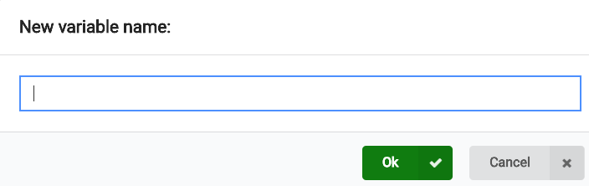

Pro-tip

Name your variables wisely! A good variable name describes what it is for or what it contains. Variable names should be lowercase, with words separated by underscores to improve readability.

***my_first_variable*** is better than ***My1stVar***

In this example we have named the variables ***int1*** and ***int2.*** Int is short for **integer** which is a computing/maths word for whole number.

|  |  |
| --- | --- |
| Once you have created the two variables they will appear in the **Variables** menu to be used with other blocks. |  |

Now you need to use an ***on button A pressed*** block and inside that put a ***set to*** block for both ***int1*** and ***int2*** and then attach a ***pick random number*** from the **Maths** blocks. Next change the number from 4 to 10 in the ***pick random*** block.

This will set the two variables to random numbers from 1 to 10 when button A is pressed. We now need to show this on the LEDs so the user can see the question.

|  |  |
| --- | --- |
|  | Now we can add the ***show number*** blocks to show the random numbers.  To make the program suitable for younger learners we have added a ***pause*** block so the number stays on the LEDs long enough to read.  The ***show string “x”*** block represents the multiplication symbol.  That last block is another ***show string*** that displays the “=” sign and then a “?” to show that it is a question. |

The process so far:

* User is prompted to press button A for a question

We now need to display the answer as this is also required by the success criteria. We will now program button B to give the answer. As we have stored the randomly generated numbers in variables when button A is pressed we can now multiply them together and show this on the LEDs.

|  |  |
| --- | --- |
|  | Again we use an ***on button pressed*** block but this time for button B and we also add the ***show number*** block. Inside that block we use another **Maths** block to multiply ***int1*** with ***int2***. |

## Test Time

We have used a few different blocks here so now is the time to test your program and make sure that it behaves as you would expect.

Give your program a name such as **math_app.hex** and **Download** it onto you micro:bit.

Make sure to check that the answer is correct a few times! If not, look at the blocks and see where the problem is and fix it as you go along.

## Stretch Tasks

* Make the program use the other maths operators (+, -, /) you could make the program change the operator when shaken for example
* Make the micro:bit play a sound prior to the answer being displayed
* Make another microbit keep score for two players (you will need to use the **Radio** blocks)
* Add a hard mode (questions between 0 and 100) when A+B are pressed

## Final Thoughts

In this project we have covered:

* Inputs
* Variables
* Random numbers
* Basic maths
* Testing and troubleshooting

And combined it to make a useful app. This is what computing is all about, using the tools to make something useful.